Haorui Chen - 10407315 - cwk1 - Binary Processing

1. function [res] = er_dl(img, SE, ep, choice)

% flip pic if dilation

if strcmp(choice, 'd')

img = imcomplement(img);

end

se_len=size(SE,1);

ind=find(SE==0);

n_l=floor(se_len/2);

[width,height]=size(img);

for k=1:ep

% pad to deal wtih edge pixels

I_pad=padarray(img,[n_l,n_l],'symmetric');

% result pic

res=zeros(width,height);

for i=1:width

for j=1:height

% extract subimage filtered by SE

Block=I_pad(i:i+2*n_l,j:j+2*n_l);

C=Block.*SE;

C=C(:);

C(ind)=[];

% erosion

res(i,j)=min(C);

end

end

img=res;

% flip back if dilation

end

if strcmp(choice, 'd')

res = imcomplement(res);

end



* 1. original chromosome image

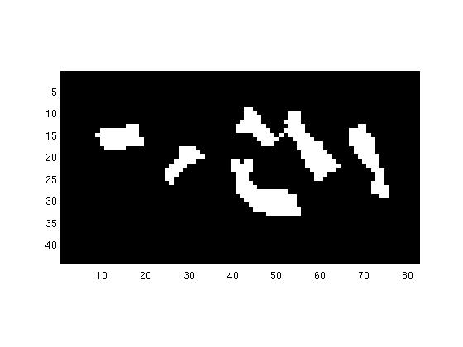 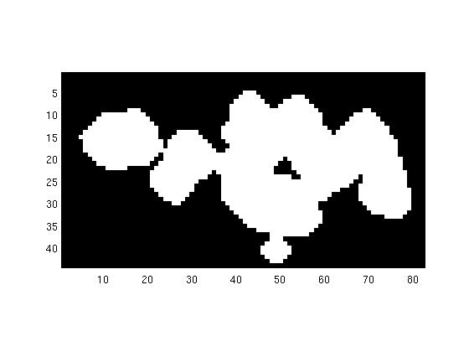

* 1. Chromosome image after 2 erosions 1-3 Chromosome image after 2 dilations
  2. Can you see why this works?

In erosion we find the min value among pixels picked out by structure element, and assign it to the pixel in the new image corresponding to that in the original image. Consequently, edge pixels of an object are given 0 value in the image while inner pixels remain unchanged, causing the effect of erosion.

In dilation we find the max value among pixels picked out by structure element, and assign it to the pixel in the new image corresponding to that in the original image. Consequently, background pixels near an object are given 1 value in the image pixels far from objects remain unchanged, causing the effect of dilation.

* 1. Compare the initial image with the result after the erosion and dilation sequence. Has this had the desired result on the image?

Yes. Size of chromosomes in image get smaller in size after erosion while get larger after dilation.



1-4 original egg image

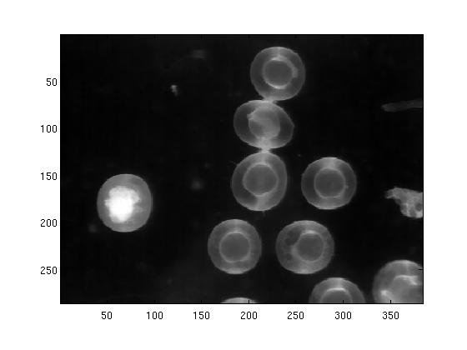 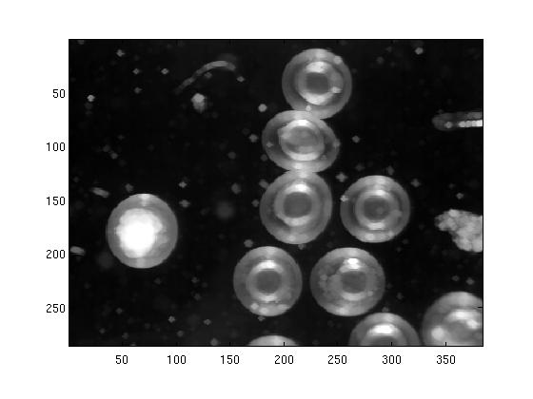

1-5 egg image after 2 erosions 1-6 egg image after 2 dilations

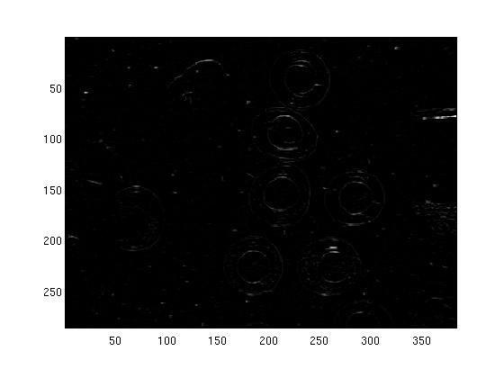 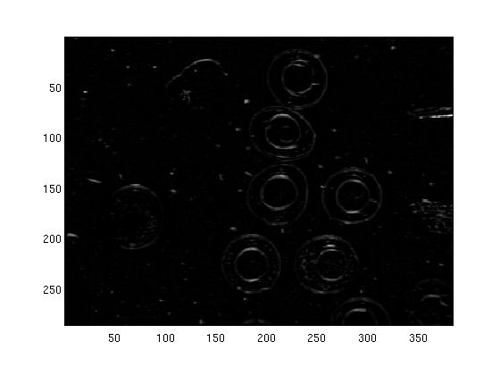

1-7 top-hat img after 1-round erosion-dilation 1-8 top-hat img after 2-round erosion-dilation

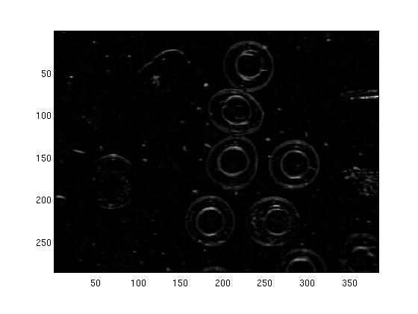 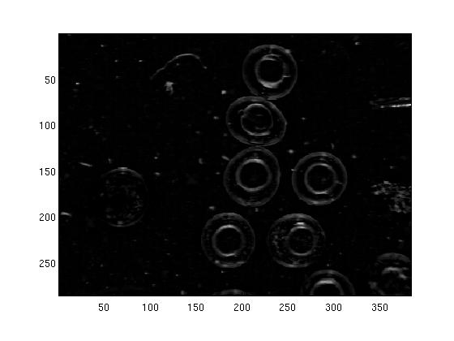

1-9 top-hat img after 3-round erosion-dilation 1-10 top-hat img after 4-round erosion-dilatio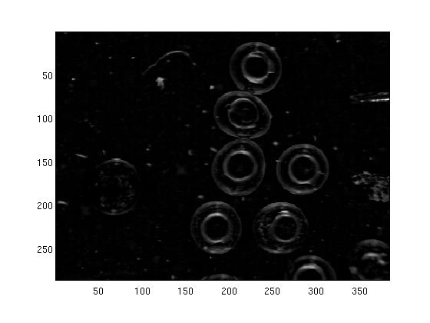 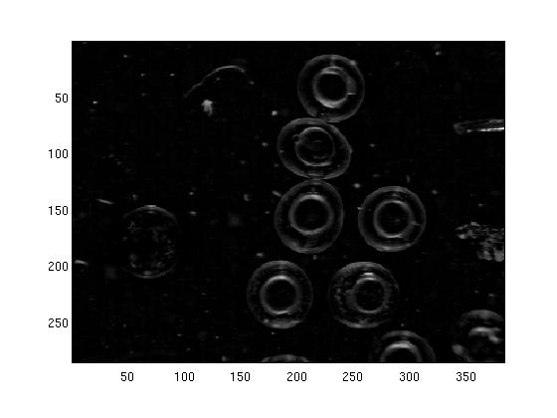1-11 top-hat img after 5-round erosion-dilation 1-12 top-hat img after 6-round erosion-dilation

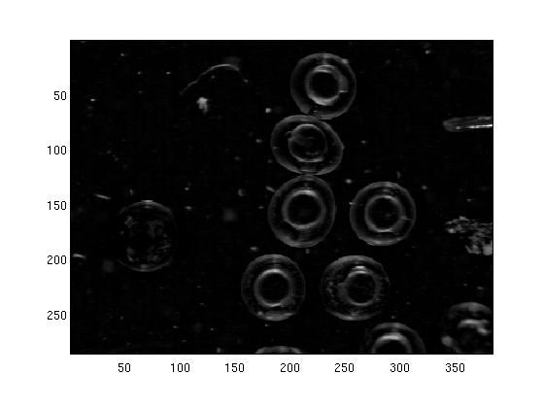 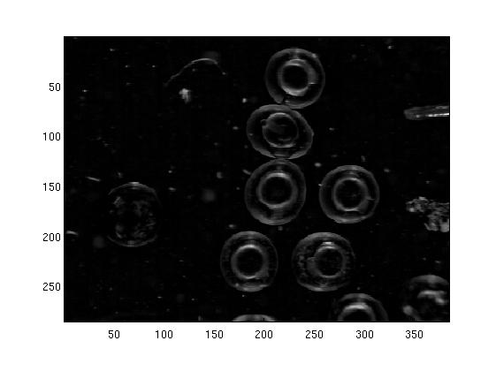

1-13 top-hat img after 7-round erosion-dilation 1-14 top-hat img after 8-round erosion-dilation

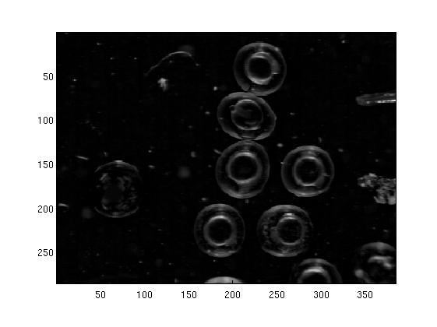

1-15 top-hat img after 9-round erosion-dilation

* 1. Has it performed as claimed?

Yes. Small bright edges and bright edges are revealed as expected.

* 1. What happens if you vary the number of erosion/dilation stages?

As number of erosion/dilation stages increase, revealed edges get brighter and more complete; also, more and more small bright objects ore revealed.

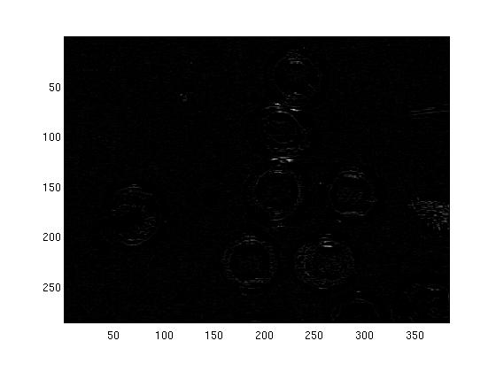 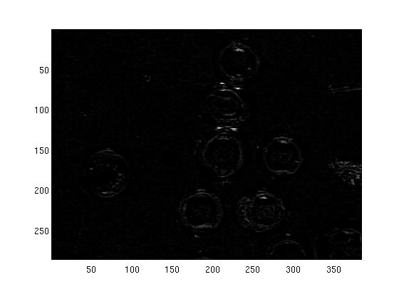

1-16 top-hat img after 1-round dilation- erosion 1-17 top-hat img after 2-round dilation- erosion

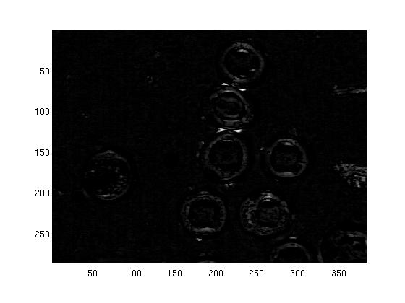 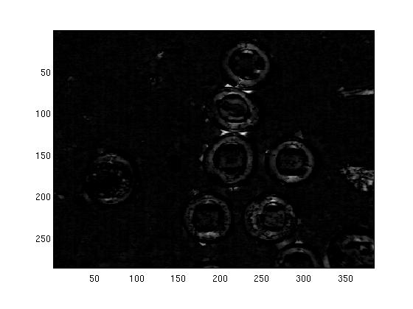

1-18 top-hat img after 3-round dilation- erosion 1-19 top-hat img after 4-round dilation- erosion

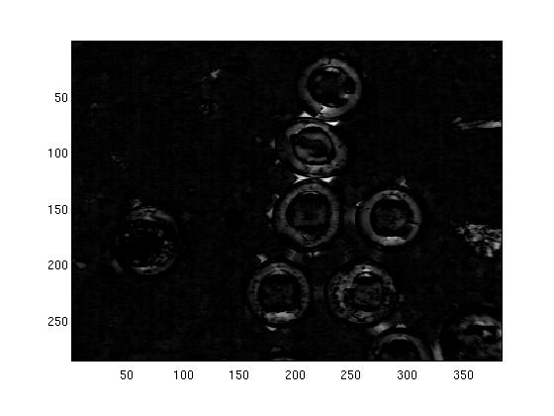 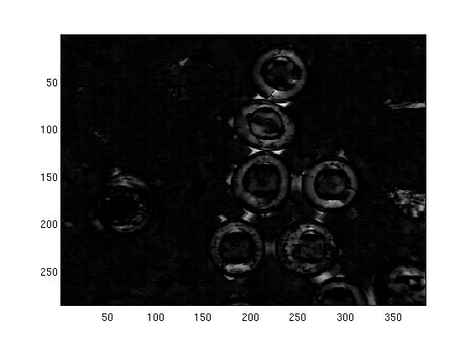

1-20 top-hat img after 5-round dilation- erosion 1-21 top-hat img after 6-round dilation- erosion

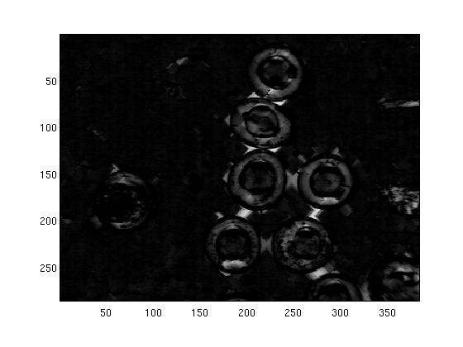 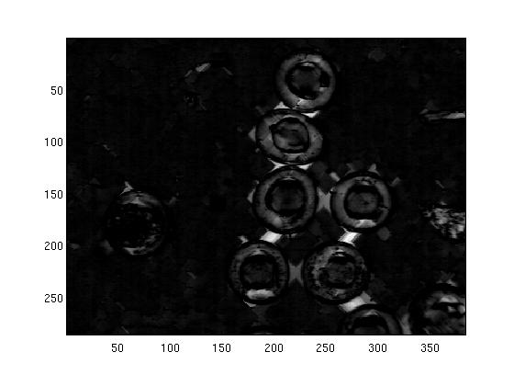

1-22 top-hat img after 7-round dilation- erosion 1-23 top-hat img after 8-round dilation- erosion

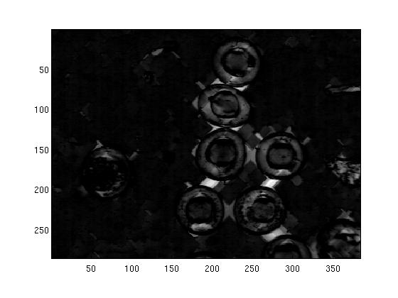

1-24 top-hat img after 9-round dilation- erosion